SOP Cloud Guardian
Azure Scout Suite
- Login to Microsoft Azure Cross-platform Command Line Interface:
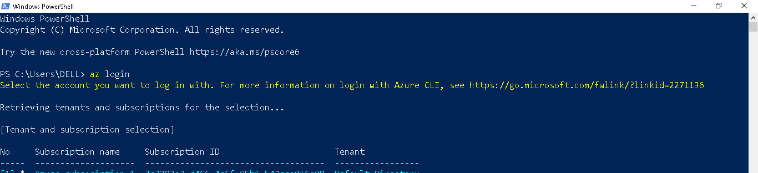
- Initiate WSL2 for Windows and Miniconda Environment:
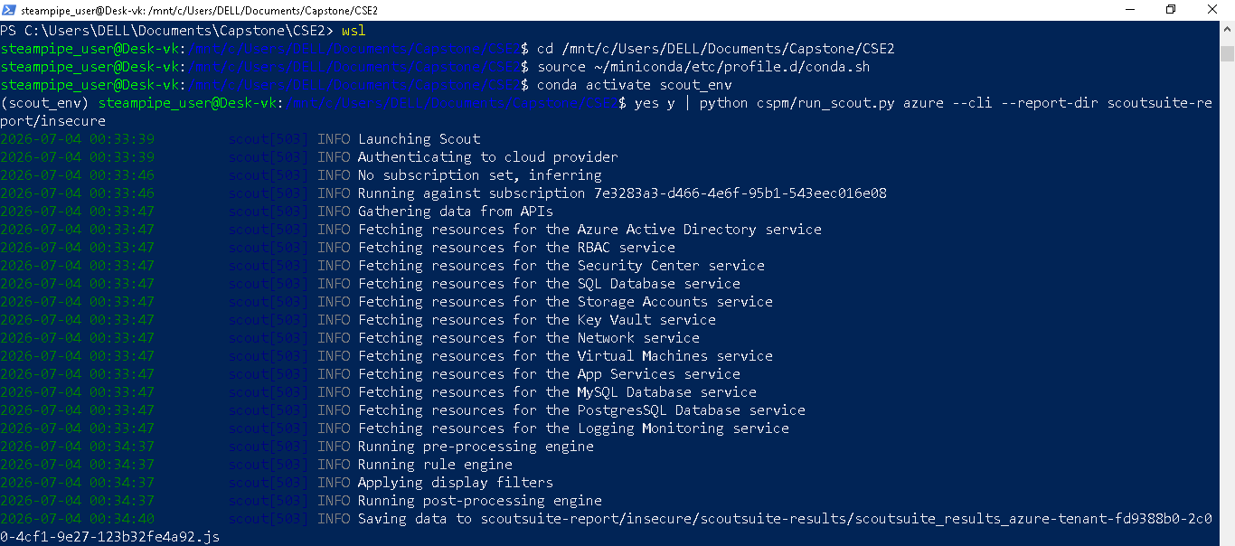
- Launch Scout Suite:

- Deactivate Conda Environment:

